

Al-Yamamah University

College of Engineering and Architecture

Department of Software Engineering

Restaurant Menu Website

Prepared by:

Mustafa Deeb 20211227

Sultan Mutairi 202211219

CIS 201 Fundamentals of Web Design

Mrs. Sara Al Sabeg

06/05/2024

Table of Contents

Introduction 3

Pages Layout: 3

Color Scheme: 3

Page Hierarchy: 4

Index Page (Home Page): 4

Products Page: 4

About me Page 5

Cart Page 6

External Links: 6

For Bootstrap: 6

For CSS: 6

For JS: 6

# Introduction

My project is a Restaurant Menu that offers different types of dishes and cuisines.

# Pages Layout:

### Color Scheme:

|  |  |  |
| --- | --- | --- |
| Color | Hexadecimal Value | Used For |
|  | **#000000 & #FFFFFF**  **& #FFFF00**  **& #007bff** | Font |
|  | **#FFFF00** | Buttons |
|  | **#FFFFF & #FFFF00** | Background |
|  | **#000000 & #FFFFFF**  **& #FFFF00** | Header |
|  | **#FFFF00** | Footer |

Table 1: Color Scheme

The fonts mainly used are Satisfy Cursive, Poppins Sans-Serif.

An index page connecting all other elements to it.

### Page Hierarchy:

I used Click Charts to create the diagram.

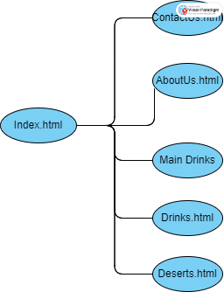

## **Index Page (Home Page):**

Includes the navigation bar, header (hero), events section for the menu, and a footer.

## **Index and Main Page:**

Final and current design:

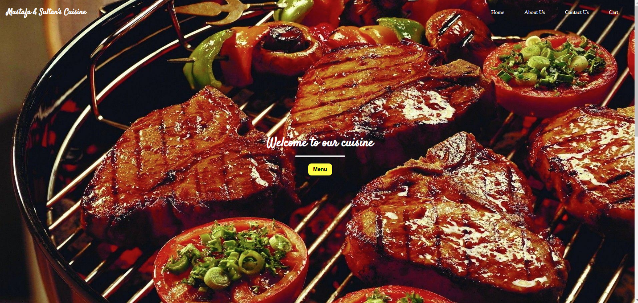

## **Category Pages:**

## **Contact Us and About Us:**

About Us Page

Hi, I'm Mustafa! I'm a software engineer, and I'm a student at Al Yamama University, and I'm currently taking CIS201, and this is my project.  
  
Education:

High School Diploma Al Faisaliah School.  
  
Certificates:  
1. Java Oracle Certification  
2. English Program at Interlink Institute

Software Engineering: Current bachelor’s Software Engineering in Al-Yamamah University 2022 – Now

Hey, I'm Sultan! I'm a Network Security Engineer, and I'm a student at Al Yamama University, and I'm currently taking CIS201, and this is my project.  
  
Education:

High School Diploma Academic City School.   
  
Certificates:  
1. Java Oracle Certification  
2. English Program at Interlink Institute

Security and Network Engineering: Current bachelor’s Network Engineer in Al-Yamamah University 2022 – Now

Skills:

* JAVA
* HTML
* CSS

# External Links:

Fonts:

@import url("https://fonts.googleapis.com/css2?family=Poppins:wght@100;300;400;500;600&display=swap");

@import url("https://fonts.googleapis.com/css2?family=Satisfy&display=swap");

## For CSS:

<link rel="stylesheet" href="/css/index.css">

Home Page + Header/ Nav Bar + Events + Footer css

<link rel="stylesheet" href="/css/MainDishes.css">

Main Dishes css

<link rel="stylesheet" href="/css/drinks.css">

Drinks css

<link rel="stylesheet" href="/css/deserts.css">

Deserts css

<link rel="stylesheet" href="/css/contactus.css">

Contact Us css

<link rel="stylesheet" href="/css/AboutUs.css">

About Us css

## For JS:

<script src="/JS/script.js"></script>

Scroll Down code to Events Section

<script>

        function submitForm() {

            alert('Your feedback has been sent.');

        }

    </script>

**References:**

[**https://harmash.com/**](https://harmash.com/)

[**https://www.w3schools.com/**](https://www.w3schools.com/)

[**https://css-tricks.com/**](https://css-tricks.com/)

[**https://www.freecodecamp.org/**](https://www.freecodecamp.org/)

[**https://fonts.google.com/**](https://fonts.google.com/)